CSA16 DATA WAREHOUSING AND DATA MINING
R PROGRAMMING
EXPERIMENT-1 ADDITION
num1=as.integer(readline(prompt = "enter the first number:"))
num2=as.integer(readline(prompt = "enter the second number:"))
num3=num1+num2
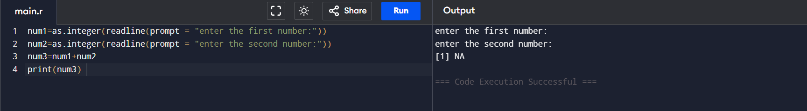
print(num3)

EXPERIMENT-2 SUBTRACTION
num1=as.integer(readline(prompt = "enter the first number:"))
num2=as.integer(readline(prompt = "enter the second number:"))
num3=num1-num2
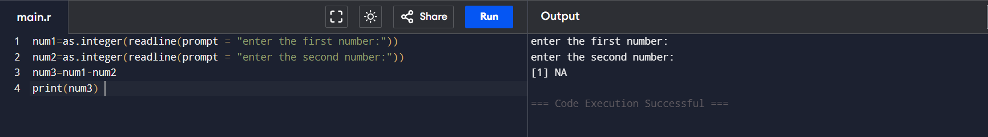
print(num3)
EXPERIMENT-3 MULTIPLICATION
num1=as.integer(readline(prompt = "enter the first number:"))
num2=as.integer(readline(prompt = "enter the second number:"))
num3=num1*num2

print(num3)
EXPERIMENT-4 DIVISION
num1=as.integer(readline(prompt = "enter the first number:"))
num2=as.integer(readline(prompt = "enter the second number:"))
num3=num1/num2

print(num3)

EXPERIMENT-5 ODD OR EVEN
num=as.integer(readline(prompt="enter a number:"))
if((num%%2)==0)
{
print("number is a even")
}else{
print("number is odd")
}
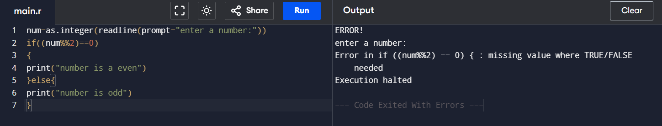

EXPERIMENT-6 MEAN,MEDIAN,MODE
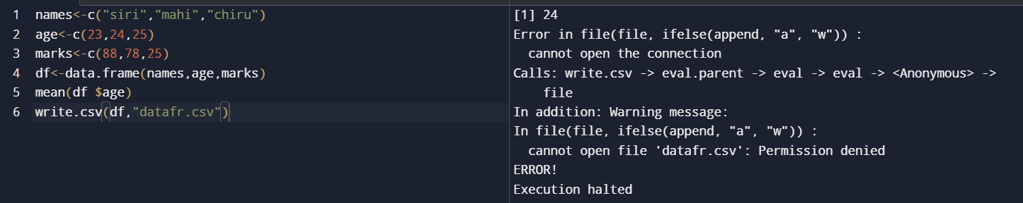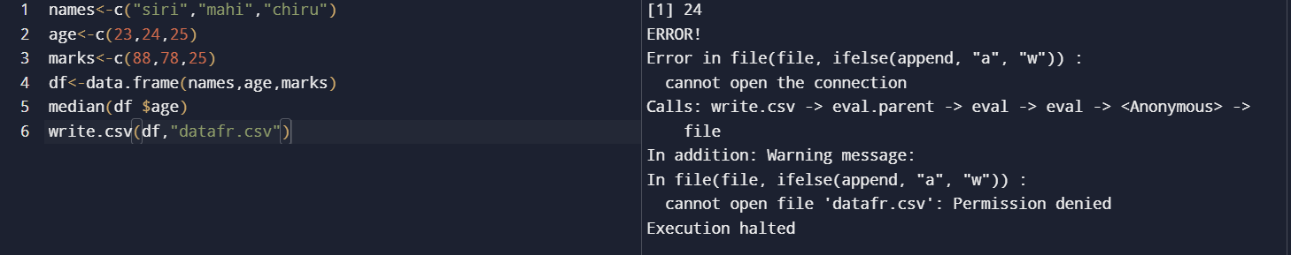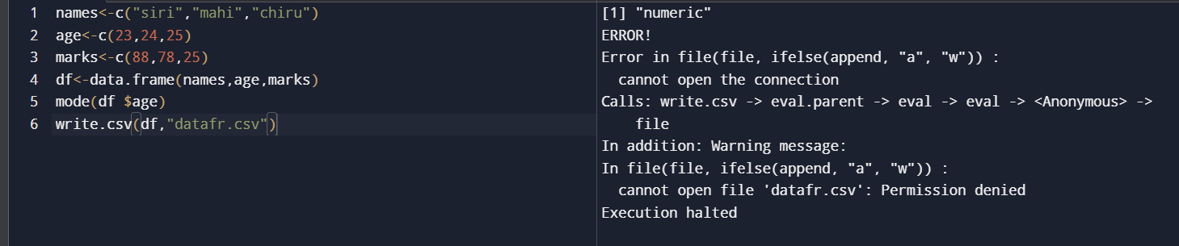

EXPERIMENT-7 SUMMARY
names<-c("siri","mahi","chiru")
age<-c(23,24,25)
marks<-c(88,78,25)
df<-data.frame(names,age,marks)
summary(df $age)
write.csv(df,"datafr.csv")
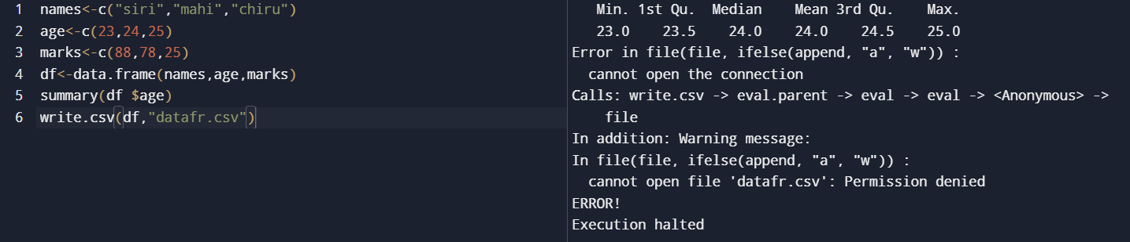

EXPERIMENT-8 GREATER AMONG THREE NUMBERS
x <- as.integer(readline(prompt = "Enter first number :"))
y <- as.integer(readline(prompt = "Enter second number :"))
z <- as.integer(readline(prompt = "Enter third number :"))
if (x > y && x > z) {
print(paste("Greatest is :", x))
} else if (y > z) {
print(paste("Greatest is :", y))
} else{
print(paste("Greatest is :", z))
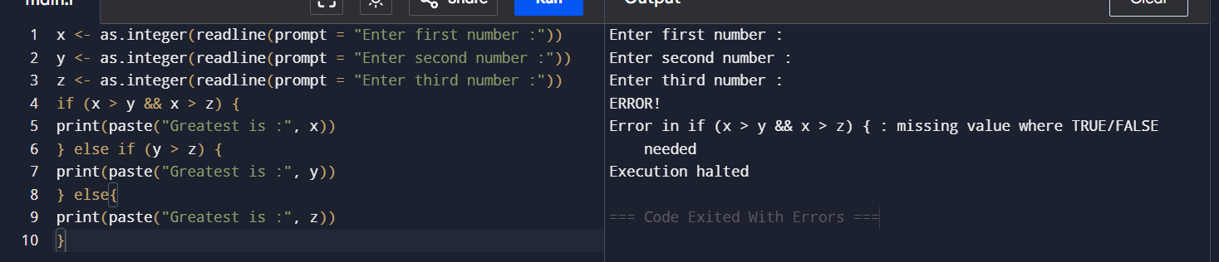

EXPERIMENT-9 IQR
names<-c("siri","mahi","chiru")
age<-c(23,24,25)
marks<-c(88,78,25)
df<-data.frame(names,age,marks)
IQR(df $age)
write.csv(df,"datafr.csv")
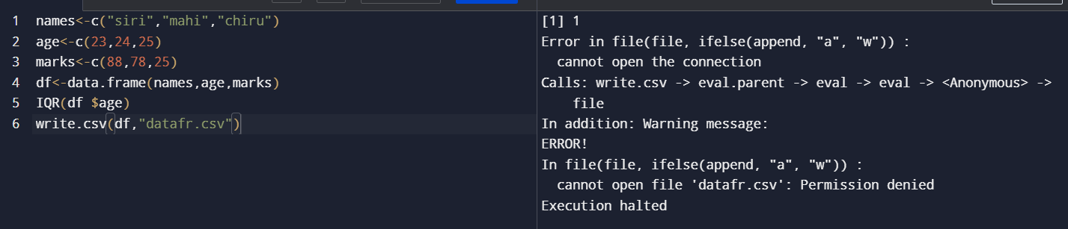

EXPERIMENT-10 QUANTILE
names<-c("siri","mahi","chiru")
age<-c(23,24,25)
marks<-c(88,78,25)
df<-data.frame(names,age,marks)
quantile(df $age)
write.csv(df,"datafr.csv")
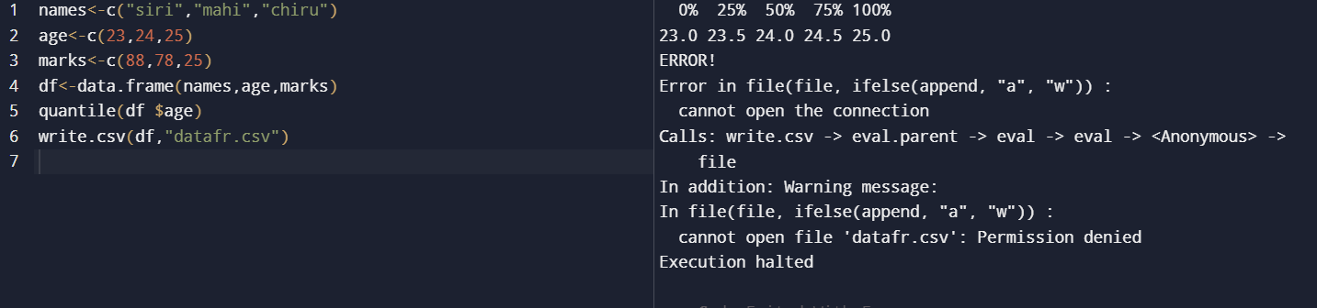

EXPERIMENT-11 MID RANGE
names<-c("siri","mahi","chiru")
age<-c(23,24,25)
marks<-c(88,78,25)
df<-data.frame(names,age,marks)
mid range(df $age)
write.csv(df,"datafr.csv")


EXPERIMENT-12 Z-SCOORE NORMALIZATION
diabetest1<-read_excel("C:/Users/M.Geetha/Downloads/NARA.xlsx")
A<-c(diabetest1$Age)
Mean<-mean(A)
Std<-sd(A)
Zscore<-(A-Mean)/Std
Zscore
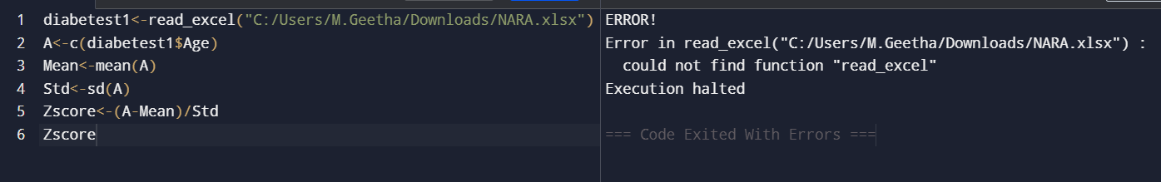

EXPERIMENT-13 MIN,MAX,MEAN,MINMAX
MEAN
diabetest1<-read_excel("C:/Users/M.Geetha/Downloads/NARA.xlsx")
A<-c(diabetest1$Age)
Mean<-mean(A)

MINIMUM
diabetest1<-read_excel("C:/Users/M.Geetha/Downloads/NARA.xlsx")
A<-c(diabetest1$Age)
Minimum<-Min(diabetest1$Age)

MAXIMUM
diabetest1<-read_excel("C:/Users/M.Geetha/Downloads/NARA.xlsx")
A<-c(diabetest1$Age)
Maximum<-Max(diabetest1$Age)

MINMAX
diabetest1<-read_excel("C:/Users/M.Geetha/Downloads/NARA.xlsx")
A<-c(diabetest1$Age)
Maximum<-Max(diabetest1$Age)
Minimum<-Min(diabetest1$Age)
MinMax<-(A-Minimum)/(Maximum-Minimum)
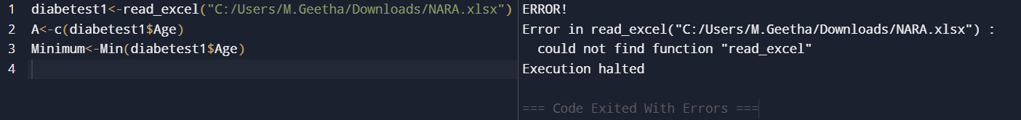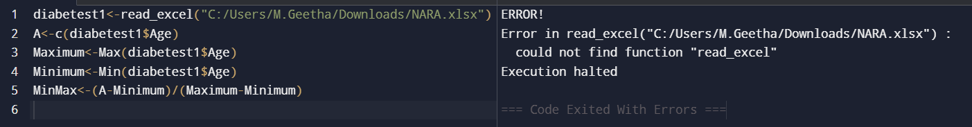

EXPERIMENT-14 BAR PLOT AND HORIZONTAL BAR
a<-c(55,67,89,80,90)
barplot(a)
a<-c(55,67,89,80,90)
barplot(a)
barplot(a,horiz=TRUE)
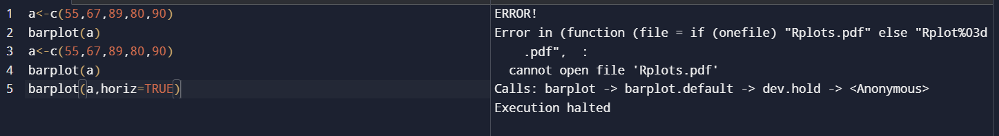
EXPERIMENT-15 BOX PLOT
names<-c("siri","chru","loki")
age<-c(23,24,25)
marks<-c(88,78,25)
df<-data.frame(names,age,marks)
hist(df$age)
boxplot(df$age)
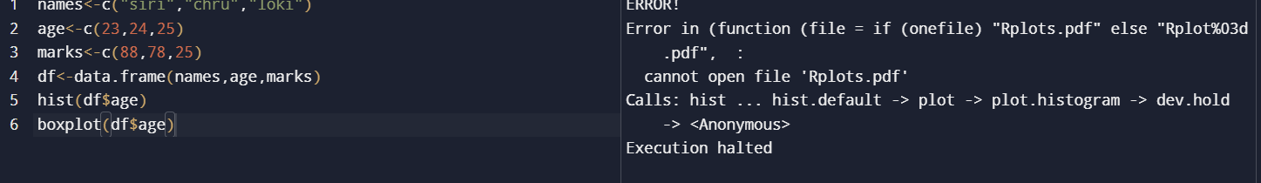

EXPERIMENT-16 HISTOGRAM
a<-c(55,67,89,80,90)
hist(a) 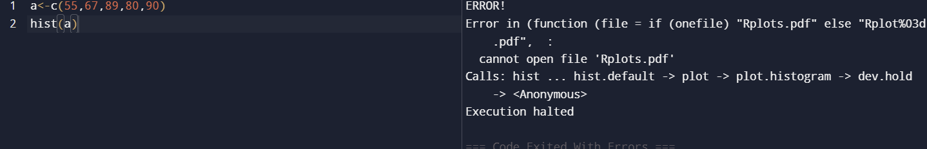

EXPERIMENT-17 CORRELATION ANALYSIS
diabetest1<-read_excel("C:/Users/M.Geetha/Downloads/NARA.xlsx")
diabetest1<-table(diabetest1 $Age,diabetest1 $Insulin)
diabetest1
chisq.test(diabetest1)

EXPERIMENT-18 SCATTER PLOT
set.seed(9)
x <- rnorm(1000)
y <- rnorm(1000)
smoothScatter(y - x)
smoothScatter(x,y) 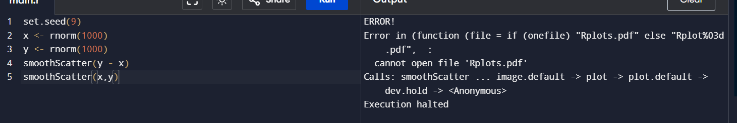

EXPERIMENT-19 LINEAR REGRESSION
Relation <- lm(diabetes$BloodPressure~diabetes$Age)
Png<- (file=”linear regression.png”)
Plot(diabetes$Age, diabetes$BloodPressure, col=”green”, main= “ Linear Regression Analysis” ,
abline= (lm(diabetes$BloodPressure~ diabetes$Age)), xlab = “BloodPressure”, ylanb= “Age”) 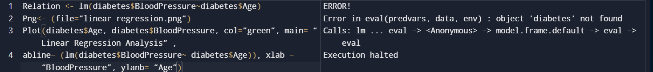

EXPERIMENT-20 MULTIPLE REGRESSION
Input <- diabetes[,c(“Age”, “BloodPressure”, “Glucose”)]
Model <- lm(Age~ BloodPressure+Glucose,data=input)
Print(model) 